NORTHWIND SALES PERFORMANCE DASHBOARD USING POWER BI

PROJECT REPORT

NAME :S.NAKSHATHRA
ROLL NO: E25FA030
TOOL USED: MICROSOFT POWER BI

1. INTRODUCTION
This project focuses on developing an interactive Sales Performance Dashboard using Microsoft Power BI with the Northwind dataset. The dashboard integrates information related to orders, customers, employees, products, categories and shipping to provide a comprehensive view of business performance.
The main purpose of the project is to convert raw business data into meaningful and easy-to-understand visual information. The report uses KPI cards, charts, tables and slicers to present important business indicators and allow users to explore the data interactively.
Users can select different years, regions and product categories, after which the visuals and KPI values automatically change according to the selected filters. This makes the dashboard useful for analysing sales activity from different perspectives.

2. OBJECTIVES
The major objectives of developing the Northwind Sales Dashboard are:
- To present important business information through KPI cards.
- To analyse the total number of orders and quantity sold.
- To examine monthly order trends and identify variations in order activity.
- To compare sales performance across different product categories.
- To analyse the number of orders handled by different employees.
- To study the geographical distribution of customers.
- To provide detailed product-level information through tables.
- To create an interactive report using year, region and category slicers.
- To make business information easier to understand through graphical visualisations.
- To provide users with a single dashboard for analysing different aspects of the Northwind business data.

3. DATASET DESCRIPTION
The project uses the Northwind dataset, which contains business information related to products, customers, orders, employees and shipping.
The Power BI data model consists of the following tables:
Table | Description
Categories | Contains information about different product categories.
Customers | Provides customer details and geographical information.
Employees | Contains employee-related information used for order analysis.
Order Details | Contains detailed information about individual order items.
Orders | Provides order-level information such as orders and freight.
Products | Contains product names, prices and category-related information.
Shippers | Provides information about the companies responsible for shipping orders.
These tables collectively provide the information required to perform sales, product, customer, employee and order analysis.

4. DATA PREPARATION
The Northwind dataset was imported into Power BI Desktop for creating the dashboard. The available tables and fields were examined and used to build the required visualisations.
The major steps involved in preparing the dashboard were:
- Imported the required Northwind tables into Power BI Desktop.
- Examined the available fields from the different tables.
- Created the required measures and calculations for the dashboard.
- Designed KPI cards to display important performance indicators.
- Created charts for monthly orders, category-wise sales and employee-wise orders.
- Developed a product-level table containing important product information.
- Created a geographical customer analysis using region/country information.
- Added slicers for Year, Region and Category.
- Configured interactions between the different report visuals.
- Arranged and formatted the visuals to create an easy-to-read dashboard.
The prepared report allows users to interact with the data rather than viewing it as a static table.

5. MEASURES AND KPI VALUES USED
Several important measures were created and displayed through KPI cards. These measures provide a quick summary of the business performance.
The main KPIs used in the dashboard are:
- Total Orders – Shows the total number of orders.
- Total Freight – Represents the total freight value associated with the orders.
- Number of Customers – Displays the total number of customers.
- Average Freight – Shows the average freight value per order.
- Total Quantity Sold – Represents the total quantity of products sold.
The values displayed by these measures can change when the user applies different slicers or filters.

6. DASHBOARD COMPONENTS
The Power BI report contains multiple views that provide different levels of analysis.
The major dashboard sections include:
6.1 Sales Overview
This section provides an overall summary of the Northwind business data using KPI cards and charts.
It includes:
- Total Orders
- Total Freight
- Number of Customers
- Average Freight
- Total Quantity Sold
- Monthly order trend
- Employee-wise order comparison
- Category-wise sales analysis
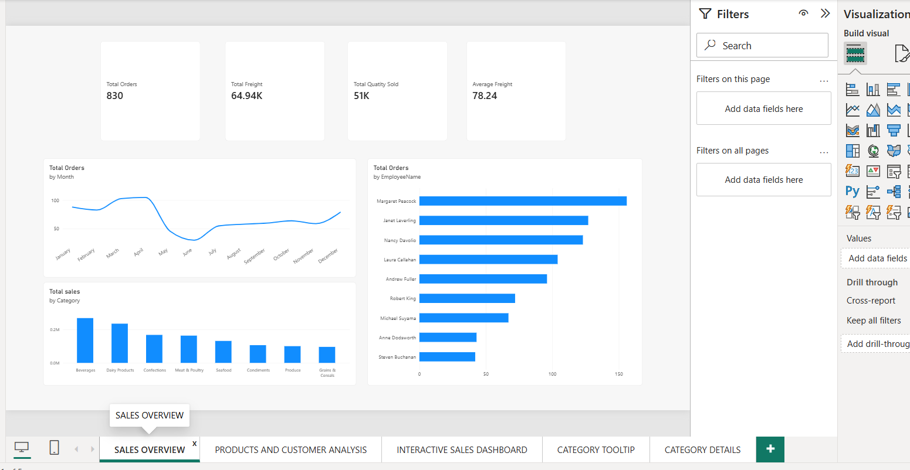
6.2 Product and Customer Analysis
This section provides more detailed information about individual products and customer distribution.
The product table contains fields such as:
- Product Name
- Category
- Total Sales
- Total Quantity Sold
A regional bar chart is also used to show the number of customers across different countries.
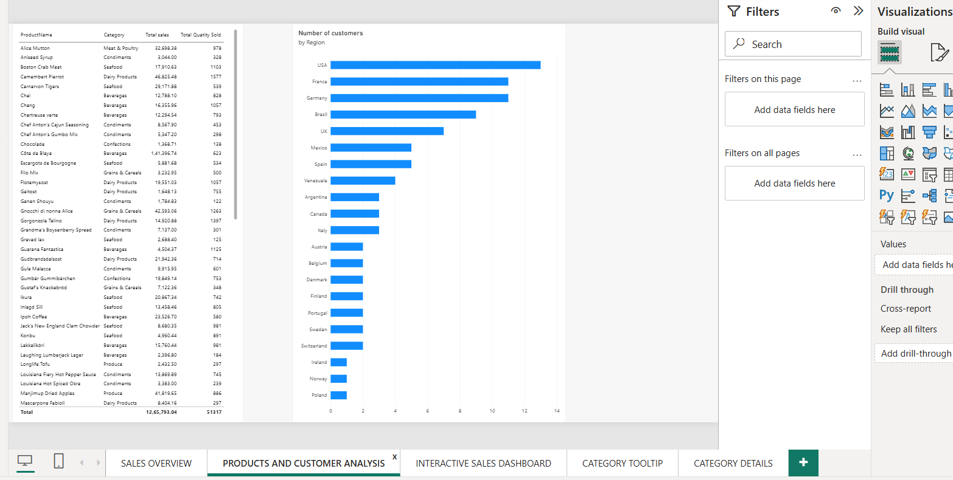
6.3 Interactive Sales Dashboard
The interactive dashboard allows users to select specific values using slicers.
The main filters include:
- Year
- Region
- Category
The page also contains KPI cards and charts for analysing monthly orders, category sales and employee orders.
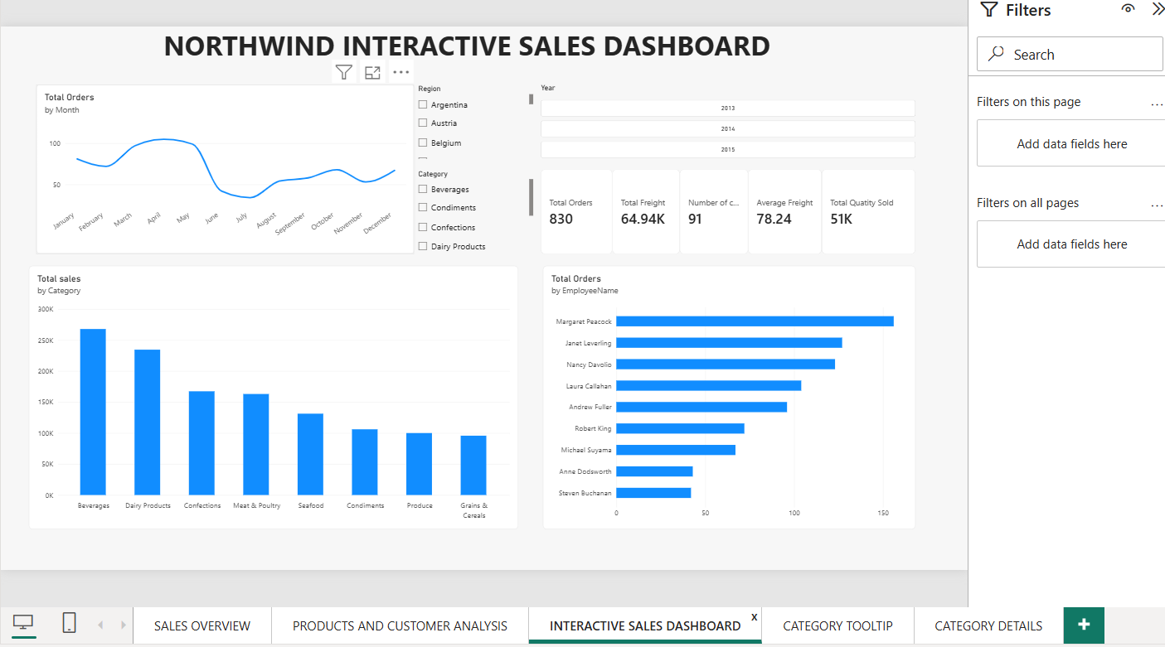
6.4 Interactive Dashboard Captured View
Another captured view of the dashboard presents the same interactive report layout. It includes the year, region and category filters along with KPI cards and different charts.
The captured view also demonstrates the use of a tooltip, which provides additional information when the user interacts with a visual.
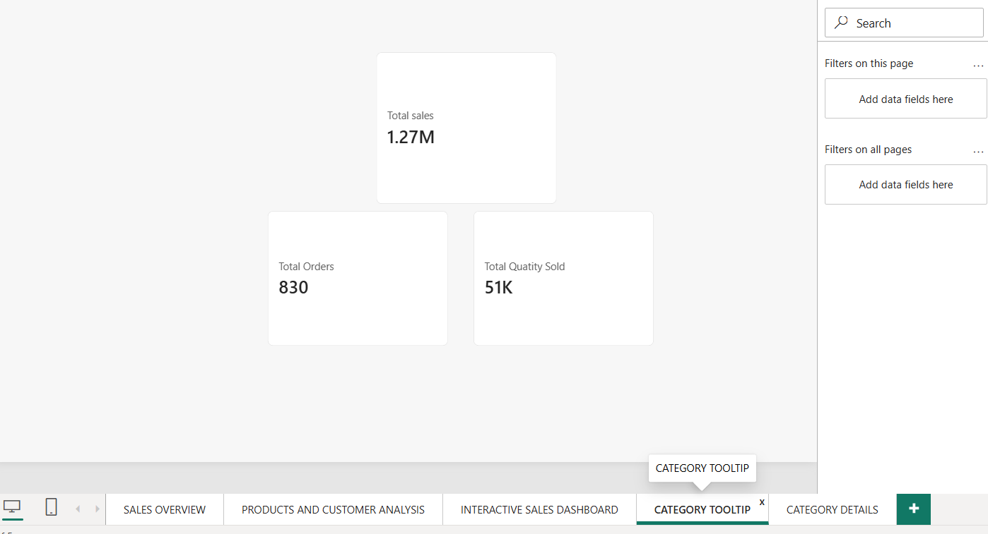

7. SALES OVERVIEW ANALYSIS
The Sales Overview page provides a consolidated view of the Northwind dataset.
In the overall dashboard view, the following values are displayed:
KPI | Value
Total Orders | 809
Total Freight | 63.96K
Number of Customers | 91
Average Freight | 79.05
Total Quantity Sold | 51K

The dashboard also contains a monthly order chart that helps identify changes in order activity throughout the different months.
The employee-wise chart provides a comparison of orders handled by different employees, while the category-wise chart highlights differences in sales contribution among product categories.

8. PRODUCT AND CUSTOMER ANALYSIS
The Product and Customer Analysis section provides a more detailed view of the data.
The product table enables users to examine individual products along with their corresponding categories, sales and quantities.
Important fields included in the table are:
- Product Name
- Category
- Total Sales
- Total Quantity Sold
This allows the user to compare products and understand their contribution to overall business performance.
The customer analysis is presented using a regional/country-wise chart. It demonstrates that the number of customers is not evenly distributed across all countries. Some regions have a considerably higher number of customers than others.

9. INTERACTIVE DASHBOARD AND FILTERS
One of the major features of the report is its interactive nature.
The dashboard contains three main slicers:
Year
The Year slicer allows users to select a particular year and analyse the business performance for that period.
For example, when 2013 is selected, the dashboard displays:
- Total Orders: 152
- Total Freight: 10.28K
- Number of Customers: 91
- Average Freight: 67.63
- Total Quantity Sold: 10K
Region
The Region filter allows the user to focus on customers or business activity associated with a particular geographical region.
Category
The Category filter enables users to analyse sales and quantity information for a selected product category.
These slicers make the dashboard dynamic because the KPI cards and charts respond to the selected values.

10. CATEGORY DETAILS
The Category Details section provides a product-level analysis of the Northwind dataset.
The detailed table contains information such as:
- Product Name
- Quantity Per Unit
- Category
- Total Sales
- Total Quantity Sold
This view helps users examine the performance of individual products instead of looking only at overall sales figures.
It can also be used to compare the quantity sold and sales contribution of products belonging to different categories.
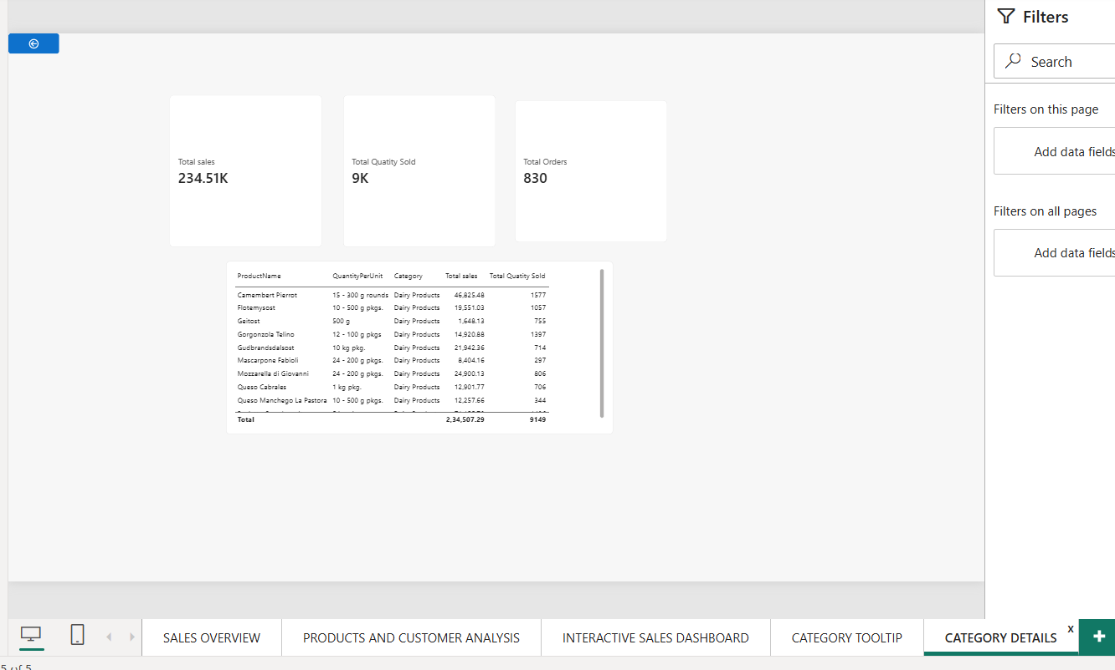
11. KEY FINDINGS
The completed Power BI dashboard provides several important observations:
- The overall dashboard records 809 total orders.
- The total freight displayed in the overall view is 63.96K.
- The dataset contains 91 customers in the overall dashboard view.
- The overall average freight is 79.05.
- The total quantity sold is approximately 51K.
- Monthly order activity varies across different months.
- Employee-wise analysis shows differences in the number of orders handled by employees.
- Different product categories contribute different levels of sales.
- Customer distribution varies across different countries or regions.
- Selecting 2013 through the Year slicer changes the dashboard values to 152 total orders and 10.28K total freight.
- The product-level table provides a detailed view of sales and quantity information.
- The interactive filters allow the same dataset to be analysed according to different business requirements.
- The simplified KPI view displays 1.27M Total Sales, 809 Total Orders and 51K Total Quantity Sold.
- Tooltips provide additional information when users interact with dashboard visuals.
Overall, the findings show how the Northwind dataset can be analysed from multiple perspectives, including time, category, employee, customer, region and product.

12. CONCLUSION
The Northwind Sales Performance Dashboard demonstrates the practical application of Microsoft Power BI for business intelligence and data visualisation. The project converts raw business information into an interactive report containing KPIs, charts, tables and filters.
The use of KPI cards provides a quick overview of important business measures, while charts make it easier to identify trends and differences. The product and customer analysis sections provide more detailed information for deeper examination.
The addition of Year, Region and Category slicers makes the dashboard interactive and allows users to analyse selected portions of the dataset. The project therefore provides practical experience in data modelling, measure creation, visualisation and interactive reporting.
Overall, the dashboard brings together sales, orders, customers, employees, products and categories into a single Power BI report and demonstrates how business data can be transformed into meaningful visual insights.

13. REFERENCES
- Microsoft Power BI Desktop
- Northwind Dataset
- Microsoft Power BI documentation and learning resources

